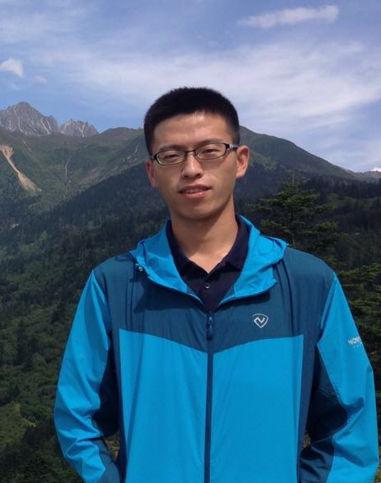
Shimin Li----- Curriculum Vitae

Name: Shimin Li Sex: Male Birth of Date: 8/20/1992 E-mail: shiminlee@163.com
Nationality: People’s Republic of China

Education:
B.Sc., Geology, China University of Geosciences, Beijing (CUGB), 2009−2013
Master, Geological Engineering, CUGB; Supervisor: Prof. Dicheng Zhu, 2013−2015
Ph.D candidate, Mineralogy, Petrology and Mineral deposits, CUGB; Supervisor: Prof. Dicheng Zhu, 2015−present
Visiting PhD student, UTD; Supervisor: Prof. Robert J. Stern, Nov. 2016−present (for 14 months)

Fellowships and Awards:
Li Siguang outstanding student award, 2015
Outstanding master's thesis, CUGB, 2015
National scholarship for graduate students, 2014
Outstanding undergraduate thesis, CUGB, 2013
PetroChina scholarship, CUGB, 2011
The Second and Third Prize Scholarships, CUGB, 2010−2012

Field work and Laboratory skills:
1. Field trip to Sanjiang area for 5 weeks (Jul. – Aug. 2015)
2. Field trip to Tibet for 15 weeks (Five times: Aug. 2016, Apr. - May. 2015, Jul. – Aug. 2014, Oct. 2013, Jul. – Aug. 2012)
3. Field practice in geological mapping for 12 weeks, Guizhou Province, China (Sep. - Dec. 2014)
4. Field practice in geological mapping for 5 weeks at Zhoukoudian, in the southwestern of Beijing, involving in almost all basic training of geological skills (Jun. – Jul. 2011)
5. XRF for major elements and LA-ICP-MS for trace elements analyses (more than 200 samples); Whole-rock Sr-Nd-Pb-Hf isotope analyses (28 samples); Laser Inductively-coupled Plasma Mass Spectrometer (LA-ICP-MS) for Zircon U-Pb dating and MC-ICPMS for Zircon Lu-Hf isotope analyses (3 months)

Experiences:
1. Apr. 19, 2015, Workshop on Tethys, oral presentation, Tibet
2. Jan 26, 2015, Workshop of National Program on Key Basic Research Project, oral presentation, Chengdu
3. Jun. 13 − Mar. 9, 2014, Washington State University, whole-rock Sr-Nd-Pb-Hf isotope analyses at Pro. Jeff Vervoort’s Laboratory
4. Dec. 2 − 4, 2013, National Symposium on Petrology and Geodynamics, oral presentation, Guangzhou
5. Jun. 20 − Sep. 10, 2013, Department of Geosciences, National Taiwan University, Adviser: Sun-Lin Chung

Research Interests and Research Experience:
Interests: Tectonomagmatism in southern Tibet (e.g., the Lhasa, Qiangtang Terrane) and its implications for tectonomagmatic evolution of ancient orogenic belts worldwide
Previous work: a)My work on the Jurassic intrusive rocks from Bangong Tso (to the north of BNSZ) in western Tibet provide petrological and geochemical evidence for the northward subduction of the Bangong-Nujiang Tethyan lithosphere (Li et al., 2014, Lithos). b) Revealing the presence of ca. 156 ± 2 Ma slab-derived adakites and OIB-type rocks from north of Gerze (to the north of BNSZ), and studying on the coeval magmatic rocks in the Western Qiangtang subterrane, to explore whether they were the product of the Bangong oceanic ridge subduction underneath the Qiangtang Terrane during the Late Jurassic (Li et al., 2016, Lithos).
Ongoing work in UTD: Geochronological and geochemical analyses of magmatic rocks to the north and south of Bangong-Nujiang suture zone to provide a constraint on subduction polarity of the Bangong-Nujiang Tethyan lithosphere.

Publications:
1. Li, S.M., Zhu, D.C., Wang, Q., Zhao, Z., Zhang, L.L., Liu, S.A., Chang, Q.S., Lu, Y.H., Dai, J.G., Zheng, Y.C., 2016. Slab-derived adakites and subslab asthenosphere-derived OIB-type rocks at 156 ± 2 Ma from the north of Gerze, central Tibet: Records of the Bangong–Nujiang oceanic ridge subduction during the Late Jurassic. Lithos 262, 456-469.
2. Li, S.M., Zhu, D.C., Wang, Q., Zhao, Z.-D., Sui, Q.L., Liu, S.A., Liu, D., Mo, X.X., 2014. Northward subduction of Bangong–Nujiang Tethys: Insight from Late Jurassic intrusive rocks from Bangong Tso in western Tibet. Lithos 205, 284-297.
3. Zhu, D.C., Li, S.M., Cawood, P.A., Wang, Q., Zhao, Z.D., Liu, S.A., Wang, L.Q., 2016. Assembly of the Lhasa and Qiangtang terranes in central Tibet by divergent double subduction. Lithos 245, 7-17.
4. Wang, Q., Zhu, D.C., Zhao, Z.D., Liu, S.A., Chung, S.L., Li, S.M., Liu, D., Dai, J.G., Wang, L.Q., Mo, X.X., 2014. Origin of the ca. 90Ma magnesia-rich volcanic rocks in SE Nyima, central Tibet: Products of lithospheric delamination beneath the Lhasa-Qiangtang collision zone. Lithos 198, 24-37.
5. Liu, A., Zhu, D.C., Wang, Q., Zhang, L.X., Li, S.M., Zhang, L.L., Zhao, Z.D., 2015. LA-ICP-MS zircon U-Pb age and origin of the Linzizong volcanic rocks from Milashan, southern Tibet. Geological Bulletin of China 34, 826-833 (in Chinese with English abstract).

